1st Grade Connection
March 9-13, 2026
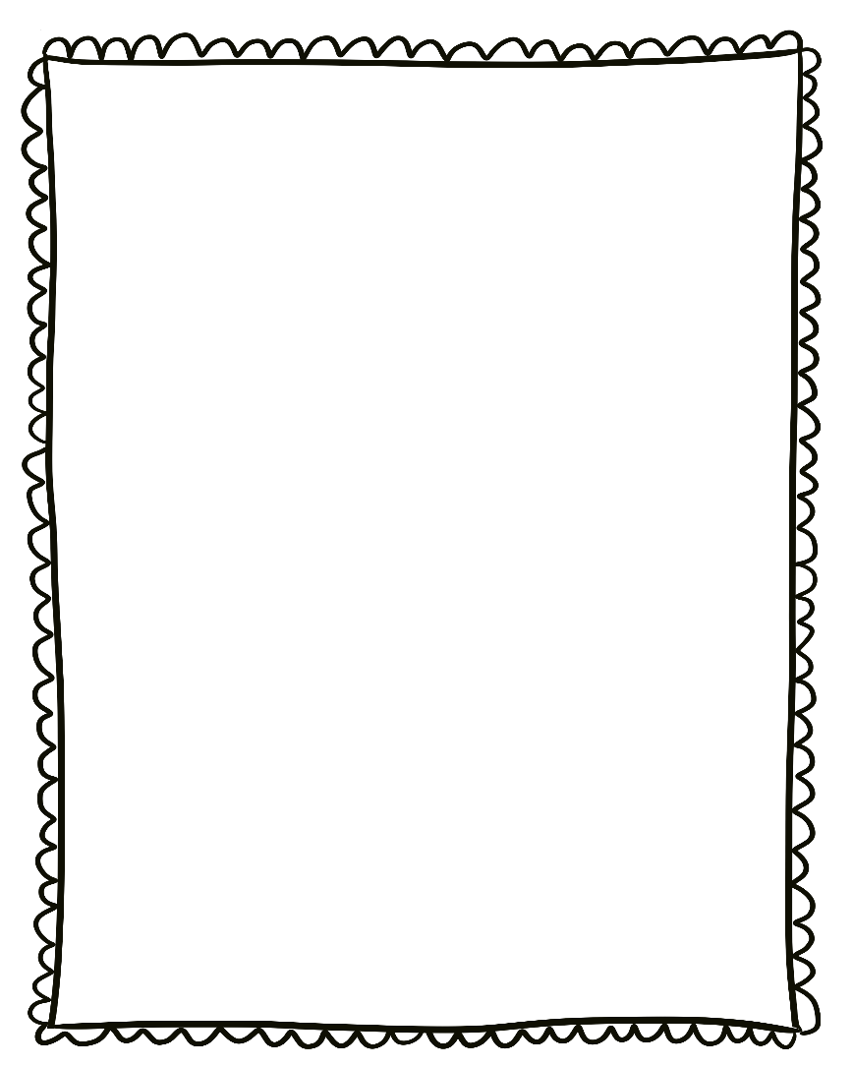
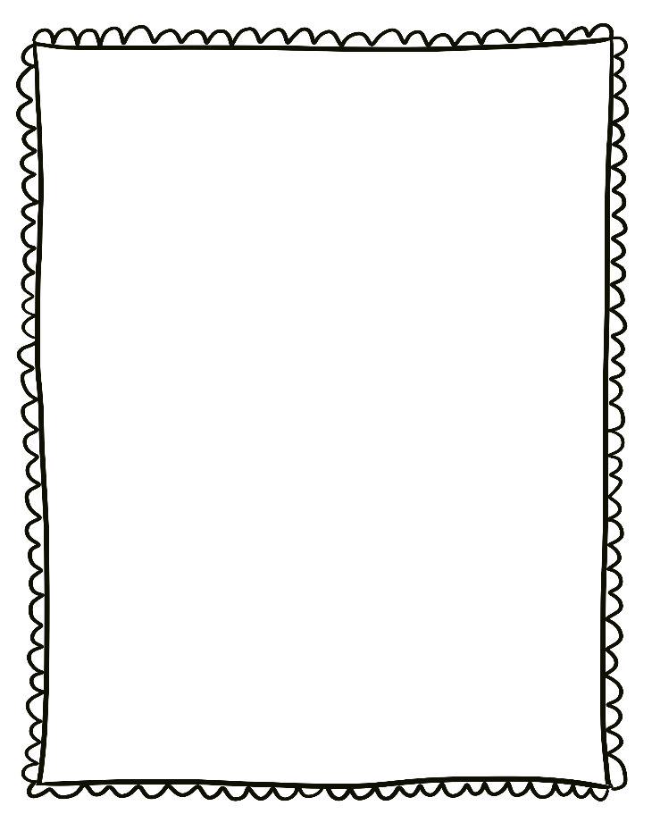
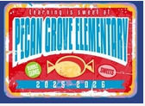
- Wednesday, March 11th: College Wear Wednesday
- Friday, March 13th: Spirit Day and School Store
- March 16th-20th -No School-Spring Break Holiday

Reminders:

- Please send a nutritious snack that is easy to eat to school with your student. All snacks must be peanut free. Examples of this include Cheez-Its, Pretzels, or baby.
carrots.

- Wear tennis shoes on PE days!

- Reading: Poetry

- Phonics: 3rd Nine Weeks review

- Writing: Poetry

- Conventions: Review

- Math: Graphing

- Social Studies: Inventors

- Science: Water conservation

Upcoming Events/Grades
What we are learning:

